**AYDIN ADNAN MENDERES UNIVERSITY**

**Engineering Faculty**

**Computer Engineering**

**Cources : CSE307 - Fundamentals of Image Processing**

**CSE408 - Microprocessors And Microcomputers**

**CSE422 - Artificial Neural Network**

**Project : Smart Glasses For Blind Persons**

**SEDA ÖZCAN**

**151805016**

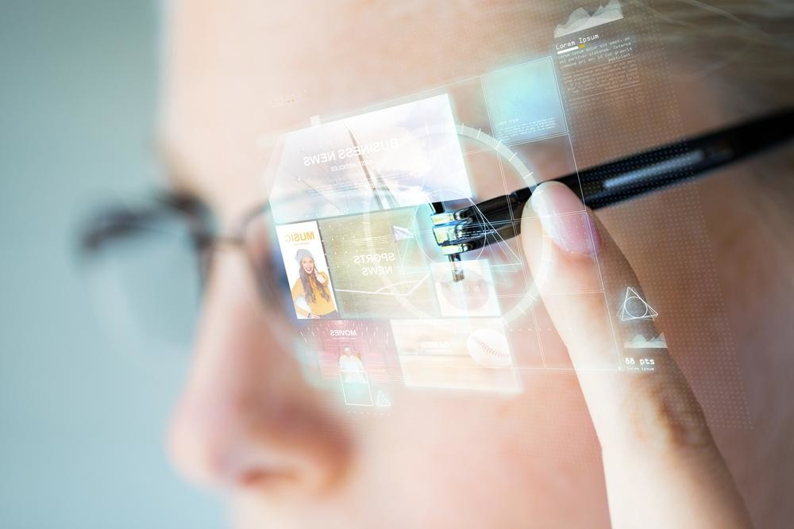

**INTRODUCTİON**

People with a significant reduction in visual acuity that cannot be medically corrected for congenital or subsequent reasons and therefore cannot survive without support are defined as Visually Impaired.Visually impaired people face many difficulties in daily life. The risk of falling and crashing is higher.

İn this project I started to develop a smart glasses for blind people.I decided to add many features.I will continue to add other.

**PROJECT AİM:**

My project aims to make the lives of visually impaired people easier.

To prevent the blind user from damaging himself by hitting obstacles in front of him and

to recognize the object or objects in front of it:these are my aims in this project

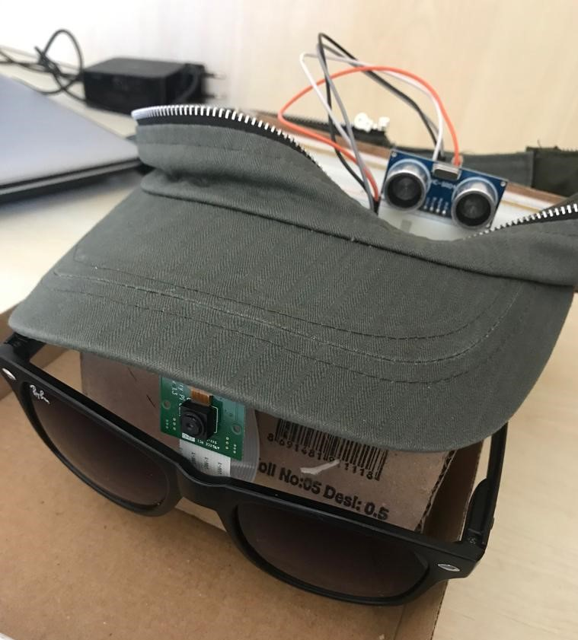

**HOW IT WORK?**

With the camera, sensors detect and warn of distance and obstacles in front of the person.

Decides what is the object in front of it and tells it connected with sound.

**HARDWARE:**

- Raspberry Pi

-Breadboard

-Pi Camera

-HC-SR04 ultrasonic distance sensor

-3 units of 10kΩ resistance

-Jumper Cables

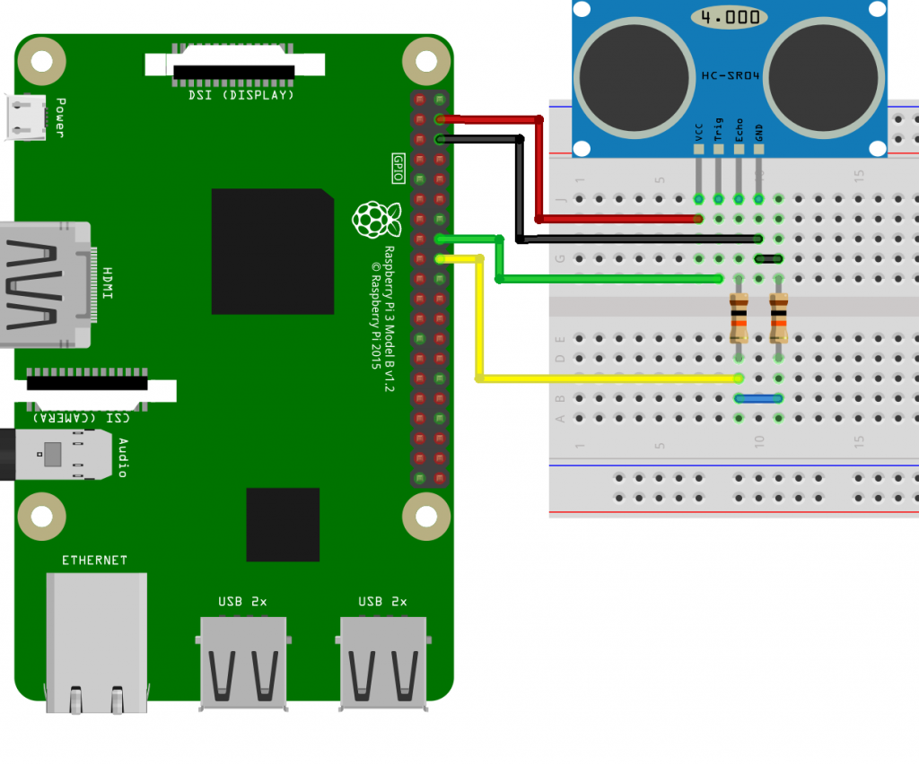

**SOFTWARE:**

In software; I used Python as programming language, OpenCV, Tensorflow.

**SENSORS:**

**HC-SR04 Ultrasonic sensor**

Hc-sr04 ultrasonic sensor sonar (Sound Navigation and Ranging) is an input source that calculates the distance from the object to the opposite object.Sonar system allows us to obtain the size of the distance using the sound waves. Such sensors are inspired by dolphins and bats. They communicate with sonar and move.

The distance between 2cm and 400cm is the range that makes the most healthy reading.

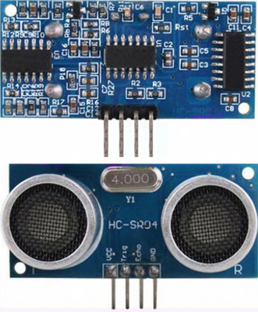

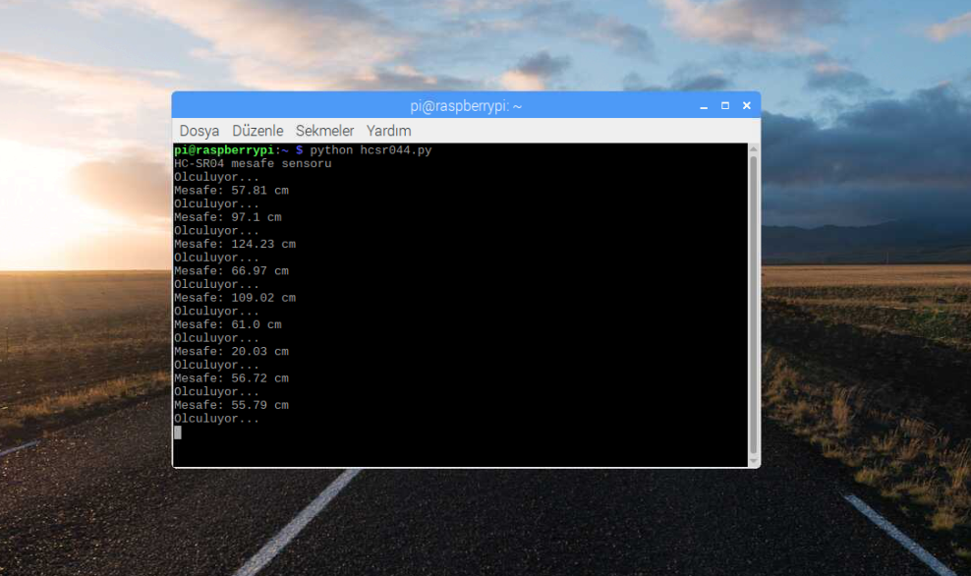

**Pİ Camera:**

The Raspberry Pi Camera Module v2 is a high quality 8 megapixel Sony IMX219 imagesensor custom designed add-on board for Raspberry Pi, featuring a fixed focus lens. ... 8 megapixel native resolution sensor-capable of 3280 x 2464 pixel static images. Supports 1080p30, 720p60 and 640x480p90 video.

**I used pi camera for object detection**

**OBJECT DETECTİON:**

Object detection is a computer technology related to computer vision and image processing that deals with detecting instances of semantic objects of a certain class (such as humans, buildings, or cars) in digital images and videos.

This guide provides step-by-step instructions for how to set up TensorFlow's Object Detection API on the Raspberry Pi. By following the steps in this guide, you will be able to use your Raspberry Pi to perform video detection on live video feeds from a Picamera or USB webcam. Combine this guide with my tutorial on how to train your own neural network to identify specific objects.

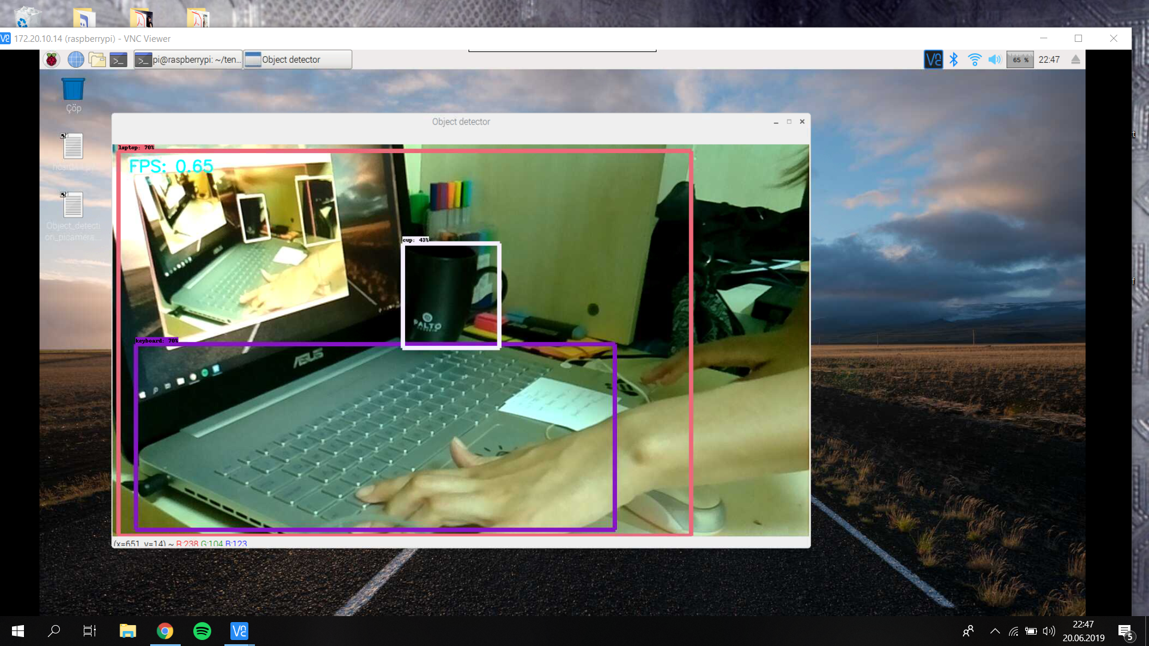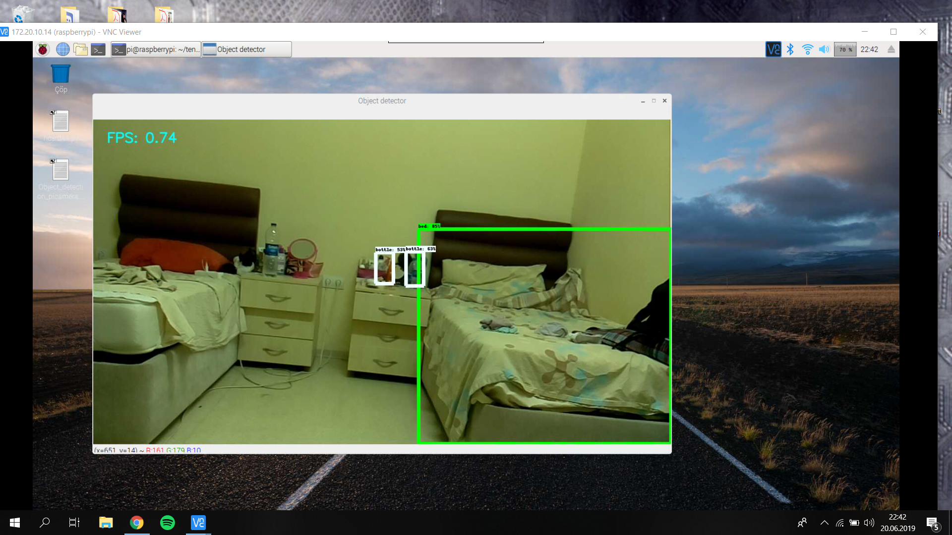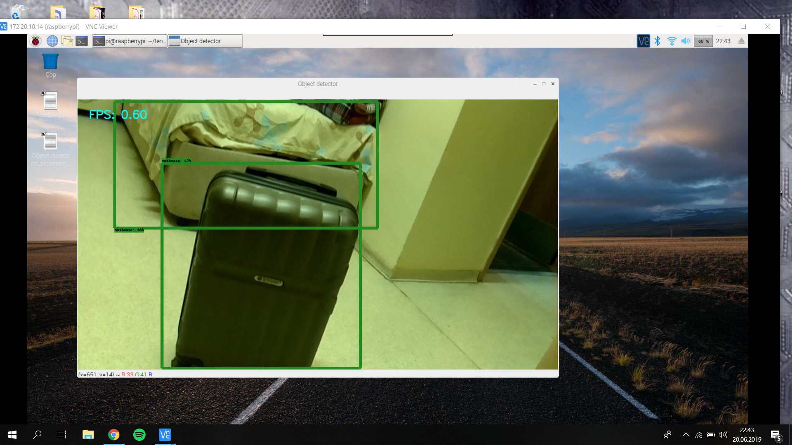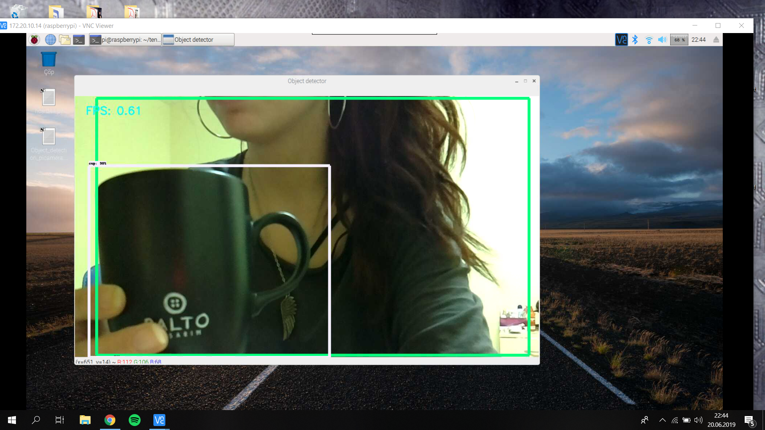

I test the object detection with some objects in my room.

**FUTURE DEVELOPMENT IDEAS:**

I couldn't complete the audio output. I will complete.

If the blind user is close enough to strike an object, a notification sound will be given.

I will add Face Recognition:

If the blind user is familiar, the person's name will be given by voice.

I will add color definition.

I will add Book reader :

the user can use the glasses to read the text from the camera and read it aloud.

I want to add more command for distance.( Short distance directions commands can be added)

I will add bluetooth headphone for voice.

REFERENCES:

<https://www.youtube.com/watch?v=npZ-8Nj1YwY>

<https://github.com/EdjeElectronics/TensorFlow-Object-Detection-on-the-Raspberry-Pi>

<https://github.com/lhelontra/tensorflow-on-arm/releases>

<http://osdevlab.blogspot.com/2016/03/how-to-install-google-protocol-buffers.html>

<https://github.com/protocolbuffers/protobuf/releases>

<https://maker.robotistan.com/raspberry-pi-dersleri-9-hc-sr04-ultrasonik-mesafe-sensoru/?utm_source=youtube&utm_medium=aciklama&utm_campaign=hcsr04_python_video>